**Architecture Design**

**PRESCRIPTION LABEL READING**



**Revision Number - 1.0**

**Last Date of Revision – 01-10-2023**

# Document Control

| **Date** |  | **Version** | **Description** | **Author** |
| --- | --- | --- | --- | --- |
| 01-10-2023 | 1.0 |  | Introduction,  Architecture, | Asif Ali  Hiren Thakkar  Khushwant Singh  Sanket Maheta  Shritama Sengupta  Shreya Mohanty |

**Contents**

Document Version Control…………………………………………………………………………2

1. Introduction……………………………………………………………………………………….4
   1. What is Architecture Design Document?..............................................................4
   2. Scope……………………………………………………………………………………4
2. Architecture……….……………………………………………………………………….……...5

# 1. Introduction

## 1.1 What is Architecture Design Document?

Any software requires an architectural design to represent the software's design. Architectural design is defined by IEEE as "the process of defining a collection of hardware and software components and their interfaces to establish the framework for the development of a computer system." Software developed for computer-based systems may exhibit any of these architectures.

Each style will characterise the following system category:

* A collection of components (such as a database or computational modules) that will perform a required system function.
* The collection of connectors will facilitate cooperation, coordination, and communication between the components.
* Conditions that govern how system components can be integrated.
* Semantic models aid the designer in comprehending the system's overall properties.

**1.2 What is Scope?**

Architecture Design Document (ADD) is a procedure of architectural design that involves a series of iterative refinements. The method can be used to create data structures, the necessary software architecture, source code, and ultimately performance algorithms. In general, design principles may be defined and refined during requirement analysis and architectural design, respectively.

**2. Architecture**

Step 1: Image will convert into Text

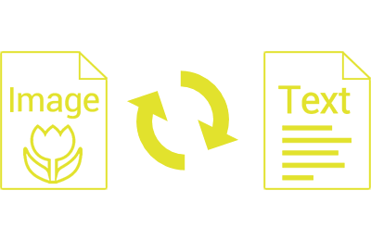

Step 2: After This Text will convert into Audio



 